Instructions to use the Workforce Data Dashboard (XLS/Excel Version)

- This dashboard is updated weekly on each Friday by 4:00pm EST
- Highly recommended before you open the file:
  - Download the XLS file to your computer by clicking the link “New – Interactive Workforce Data Dashboard (Excel)” on https://lvwib.org/data/ as shown below:
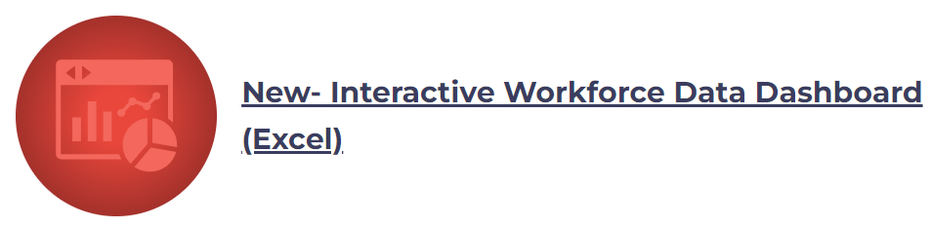
  - On Windows PC, go to your “Downloads” folder and find the downloaded XLS file
    - “Right click” on the file you’ve downloaded -> go to “Properties”
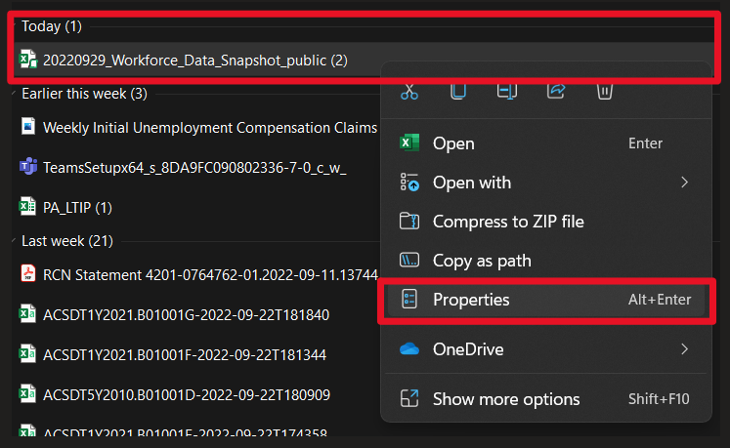
    - In “Properties”, scroll down to the “Security” section and click “Unblock”. This will allow interactivity (e.g. buttons) within the Excel file and will only apply the security settings for this spreadsheet. You may choose to skip this step if you do not need to interact (see below).
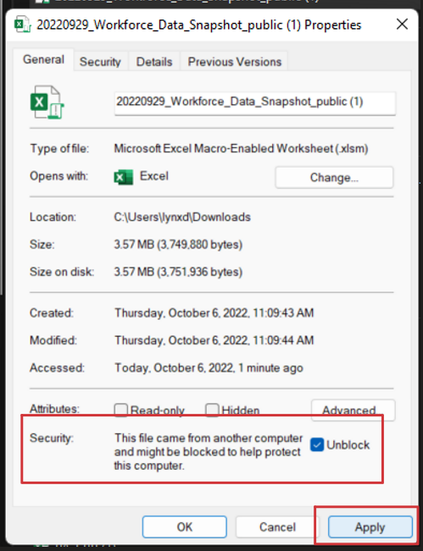
- Open the Excel file you’ve downloaded. Assuming you’ve followed the steps in the above section. You will be prompted to allow macros to run, so click the “Enable Content” button as shown below:
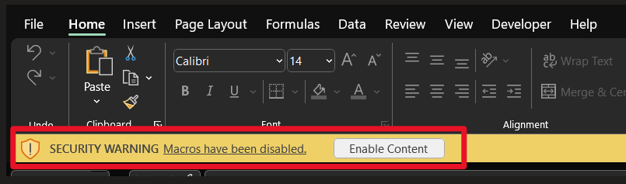

Interactivity
- By unblocking the Excel file you can now utilize the buttons to navigate within the dashboard and generate graphs
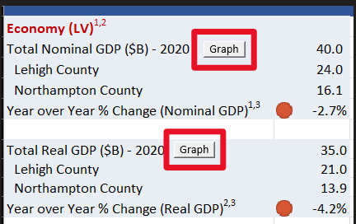

- Once on a graph tab, return to the main dashboard by clicking on the button “Back to Dashboard” on the right of the graph.
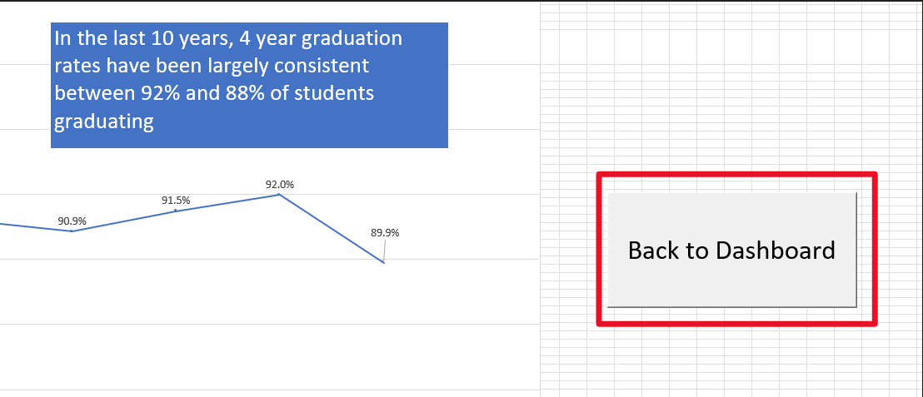
- Please contact Lillian Rodriguez lrodriguez@workforcelv.org with any questions or feedback

